**Mr. Montante**

**7th grade Social Studies Packet**

**Questions can be answered via email:** [**mmontante@nfschools.net**](mailto:mmontante@nfschools.net)

**Also you can join my Remind at the following website:** <https://www.remind.com/join/montante2>

**If technology is available at a later date you can do the same assignment online. I have detailed instructions on my webpage on the Gaskill website.**

**To complete this packet answer all questions in complete sentences. Please note any special directions on pages inside the packet.**

**Student Objectives:**

* **Students will examine the impact (change) of Hamilton’s economic plan on the constitution.**
* **Students will examine the impact of Louisiana Purchase on the constitution.**
* **Students will examine the impact of Marbury v. Madison on the constitution.**
* **Students will examine the impact of the war of 1812 on the constitution.**
* **Students will examine the impact of the Monroe Doctrine on foreign policy.**

**Alexander Hamilton’s Economic Plan**

After the constitution was approved by the states it became the government of the United States and George Washington was voted the first president of the country. Presidents have a lot of power and responsibilities. So much that they need to assign certain duties to secretaries, each having a certain job. George Washington picked Alexander Hamilton for the job of secretary of the treasury. He was a big supporter of the constitution when they were trying to pass it. Now as secretary of the treasury, Hamilton was responsible for the money of the United States and also how the economy may run.

1. What is Alexander Hamilton’s job?

With a new government in place with the constitution came new problems, especially the economy. The states had built a large **debt** (money they owe) because of the American Revolution. Hamilton wanted to tackle this debt by having the new federal government take on all states debt and make it one big one, borrow money to pay it off but with a lower interest rate (money you have to pay back). This upset some states because they already paid back their debts, now they would be paying back again for other states. Two Southerners opposed Hamilton’s idea. They were Thomas Jefferson and James Madison, two people very important because they helped make the constitution and worked for George Washington. Hamilton was able to reach a compromise and get support by moving the US capital to the south between Virginal and Maryland to create Washington D.C.

1. How did Hamilton want to tackle the debt problem?

Hamilton next wanted to create a Bank of the United States. This bank would be able to collect taxes, hold government money, and make loans to the government and borrowers. Again Jefferson and Madison had a problem with this plan. They called it “unconstitutional” or not allowed by the constitution because the power to make a national bank was not listed in the constitution. Hamilton argued back that is was an “implied power” or can be done under the wording of the constitution that the government would be doing what is “necessary and proper” to carry out its duty.

1. Why did Jefferson and Madison not want a national bank?

In 1791, Hamilton won when Congress passed a bill that allowed the opening of a national bank for 20 years. The final fate of the bank was up to President George Washington, he end up deciding the bank was best for the financial success of America so he signed the bill into law.

1. Opinion: Does George Washington passing the bank change the constitution? Explain. (Consider Jefferson and Hamilton’s arguments.)

Hamilton also wanted to help America develop industry. Most of the country was built on plantations, farming, and shipping out raw materials. Instead Hamilton wanted to keep raw materials like lumber, cotton, indigo, etc. and make it into goods that could be sold in America and across the ocean in Europe. To put it simply, America was sending out stuff, other countries took that stuff, made it into things people would want, (cloth, clothes, furniture) and sell it back to America. Hamilton wanted to make it in America to help American business. Hamilton’s way of doing this was by passing a special tax called a **tariff**. A tariff is a tax placed on foreign goods, it would raise the price on things from Britain and France. Hamilton figured this would make the goods as expensive as or more expensive than American made products. Hamilton also wanted the government to lend out money to help businesses grow.

1. Before Hamilton’s plan where would America get most of its finished goods (cloth, clothes,) from?
2. What is a tariff and how does it help American business?

Jefferson again was opposed to these plans. Jefferson would rather have had a nation of farmers working hard and worrying about just themselves and not the whole country, while Hamilton’s vision was more about the future and competing with European countries for economic power. This split was not just future visions it also happened because of the way the two individuals viewed the constitution. Jefferson followed the constitution word for word while Hamilton pushed the limits and some may argue broke the limits with plans of national banks, high tariffs, and lending out national money to business.

As time went on Hamilton and Jefferson’s idea spread its influence. Political Parties would ultimately grow from these two ideas. Jefferson’s ideas would win the battle though and he and Madison, who thought so much alike would become president. Hamilton himself would also disappear from politics when he was shot and killed in a duel.

1. Why did Jefferson and Hamilton have so many political battles? Explain.
2. Who wins the battles of Hamilton and Jefferson? Explain.

**Louisiana Purchase**

The year is 1803 and France is having all sorts of revolutions and wars and basically running out of money. Instead of asking their friends, America, for money, they wanted sell them something. They were offering up 827,000 square miles of land in the Louisiana territory (Land immediately west of the U.S. border) for $15 million dollars. The U.S. President at the time was Thomas Jefferson and he had to decide if he wanted to take the deal that would basically double the size of the United States.

**Behind the Deal**

Originally Thomas Jefferson was only try to buy the port city of New Orleans and the mouth of the Mississippi River into the Gulf of Mexico. This deal would have helped America ship goods in and out of the country much easier but the French Emperor was not planning on selling. As mentioned before, all the troubles France started to catch up to their pocket book, so they made a very generous offer to America.

1. What was Jefferson originally trying to buy?

**Jefferson’s Decision**

Jefferson decides to take the deal seeing it as too good to pass up but it was met with a lot of opposition. People that opposed it stated that the power to buy land was not stated in the constitution and it definitely was not the President’s power. Jefferson had to use the same counter argument Hamilton would use on him as “necessary and proper” for him to do the job. Right or wrong, the purchase of the land made America double in size, changed the powers of the President, and would have huge impact of American politics and people would explore than later settle on this land.

1. Why did people oppose buying this land?
2. How did buying this land change the constitution?

**Exploring the Land**

Even though the French owned this land for decades it was still very unexplored and unsettled. The French only used the colonies as trading post so there was not a lot of towns and places to buy supplies but, it was filled with animals, plains, mountains and Native Americans. Many also believed there might be some sort of water route you could take to get from the Atlantic Ocean to the Pacific Ocean. Jefferson sent in an exploration team led by Meriwether Lewis and William Clark. They left in May of 1804 with 40 men up the Missouri River.

Along the way Lewis and Clark met many Native American tribes. Some meetings were smooth and other had high tension. Along the way a Native American women named Sacagawea who joined them as a translator so they could communicate with other tribes. The journey was long, tiring, and at some parts dangerous but in 1805, the team reach the Northwest Pacific Ocean but they did not stay in the water at all times. Parts of the trip the men had to carry boats river to river. The team would return home in late 1806 and although they found no pure water route they had maps of the new area, sketches of the wildlife, and journals of the trip.

1. Opinion: Would you consider Lewis & Clark’s journey a success or failure. Explain.

**Marbury vs Madison**

Introduction

Marbury v. Madison (1803) was an important legal case in United States history. It was the first time the Supreme Court declared that an act of Congress was unconstitutional, or against the country’s set of rules. Marbury v. Madison established the idea of **judicial review**—the power of the Supreme Court to decide whether laws agree with the Constitution.

1. What is judicial review?

Background

In the 1800 presidential election, John Adams lost to Thomas Jefferson. Before he left office, Adams created a number of new positions and filled them with members of his political party. William Marbury was appointed as one of the new judges, but he did not receive his order before Jefferson became president. Marbury could not take office without the official order. Jefferson told his secretary of state James Madison to not deliver it to Marbury. Marbury then asked the Supreme Court to force Madison to deliver the order.

1. What did Marbury want? Why was he taking Madison to court?

Decision

Chief Justice John Marshall wrote the decision in Marbury v. Madison. The court found in favor of Madison on February 24, 1803. The decision said the law that gave the court the power to force Madison to deliver Marbury’s order was unconstitutional. This decision established the Supreme Court as the ultimate interpreter of the United States Constitution.

1. Who won the decision and why?

**War of 1812**

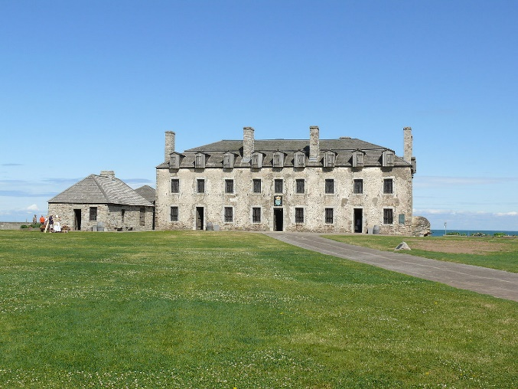The war of 1812 is a war that was actually between the years of 1812 – 1814. It is between the United States and Britain (with Native American allies). Some call it the second war for United States independence. The war is fought all over the continent. United States and Canadian borders saw battles (Fort Niagara was active at this point.) There was also battles in Baltimore (the poem that becomes our country’s national anthem was written about this battle.) The British burned down the White House, and there was a battle in New Orleans. Neither America nor Britain really win or lose this war. You could say America had a moral victory because they proved they could go toe to toe with British but neither side really gained any land or anything of note. The only real losers in this war were probably Native Americans as the saw America grow in power and start to move west.

1. Who fought in this war?
2. Who were the losers of this war? Explain.

At home the war had different impacts. The political party Hamilton helped create was called the Federalist and they really did not want to go to war. They did things like refuse to pay taxes, boycott war loans, refuse to help the troops, they even wanted to add constitutional amendments that would limit congressional, presidential powers and the 3/5 compromise (they thought it gave too much power to the southern states). The federalist states of New England even talked about seceding (states leaving the country to become their own nation) if they didn’t get their way. The war raged on and America came out of it fine but now the Federalist looked back and the party never again had the same power it used to under Hamilton and John Adams.

1. How did the Federalist plan to resist the war? Give 3 examples.
2. What happened to the Federalist Party after the war?

**Monroe Doctrine**

In the 1810s and1820s many South American colonies were gaining their independence, becoming new countries. The President of the United States at this time, James Monroe, was afraid that European countries might try and come back to North and South America trying to build empires and take over the new countries. Monroe decided to make a statement to let Europe know it was not going to happen. He had two major points in his doctrine:

A) That the United States would not allow European countries to start new colonies or to interfere with independent countries in the continents of North America or South America.

B) That the United States would not interfere with existing European colonies nor get involved with conflicts between European countries.

He promise to stop them from coming back but will not get involved in anything that does not concern the United States.

1. Consider the two main points of the doctrine: what do you think Monroe was trying to do with this statement to Europe?

The Monroe Doctrine is another piece of early American policy that helped shape the future of this country. This doctrine made other countries think twice about coming to the western hemisphere. The United States promised to get involved (more than likely with military action) in any conflicts involving their neighbors. This promise is not an empty one as you will learn in a later date that the United States got involved several times in the 1900s.

1. How active will the United States become in other countries’ activities because of the Monroe Doctrine? Explain.

**STOP!!! TURN by 5:00 PM Friday May 22nd.**